My Major Project in Flutter

In this Project I will create an E-Learning App in Flutter

In this Project I will add

* Login and Sign-Up, Logout, by using Shared Preferences
* Burger Menu
* Adding Almost all widgets that I studied in this internship program.
* In this I added YouTube Videos, Website, Learn & Quiz with related Studied Topics like Flutter, Java, C++, Linux, JavaScript etc.
* In Quiz you can get random question by compiler that I already set and you also see your result also
* I also added a contact Page
* I also added Splash Screen and many more

**Created by:**

Abhishek Chaudhary

Android App Development using Flutter

April Batch 2021

Verzeo

Working of My Major Project in Flutter

When you run this project, you see a **Splash Screen**

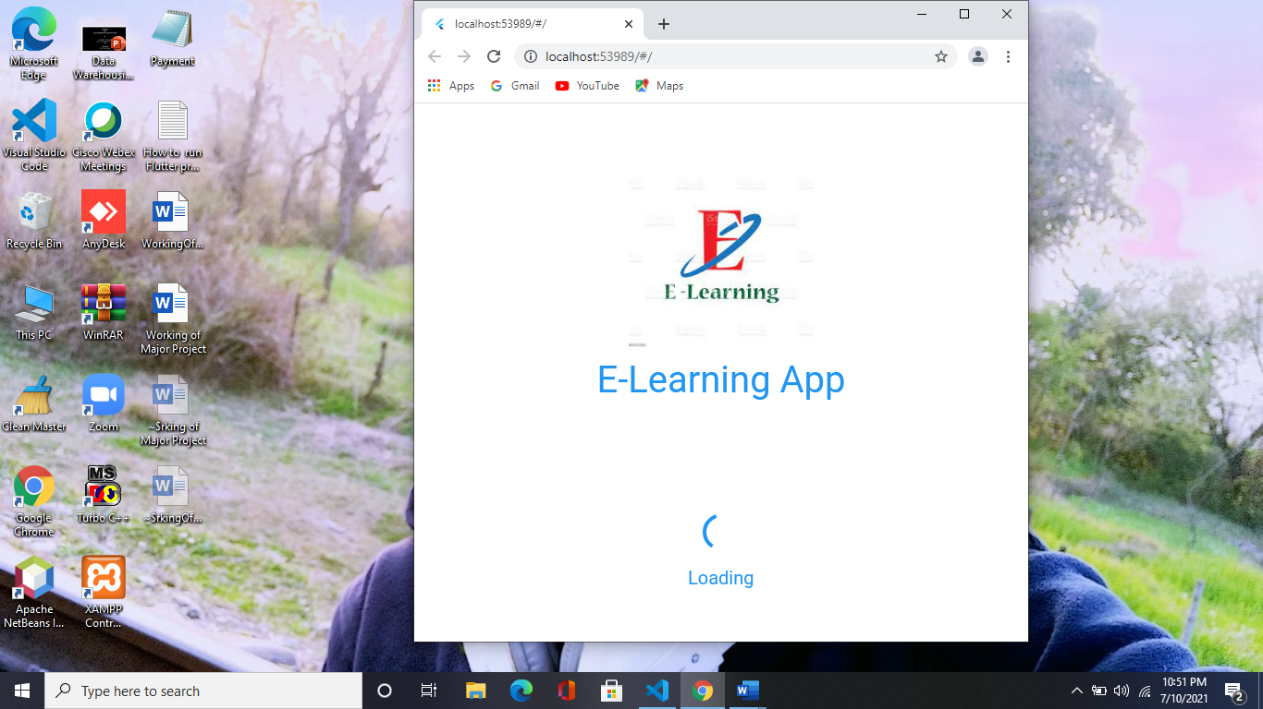

After this Splash screen you see a screen in that screen you see Two Buttons **Login** and **Sign Up**

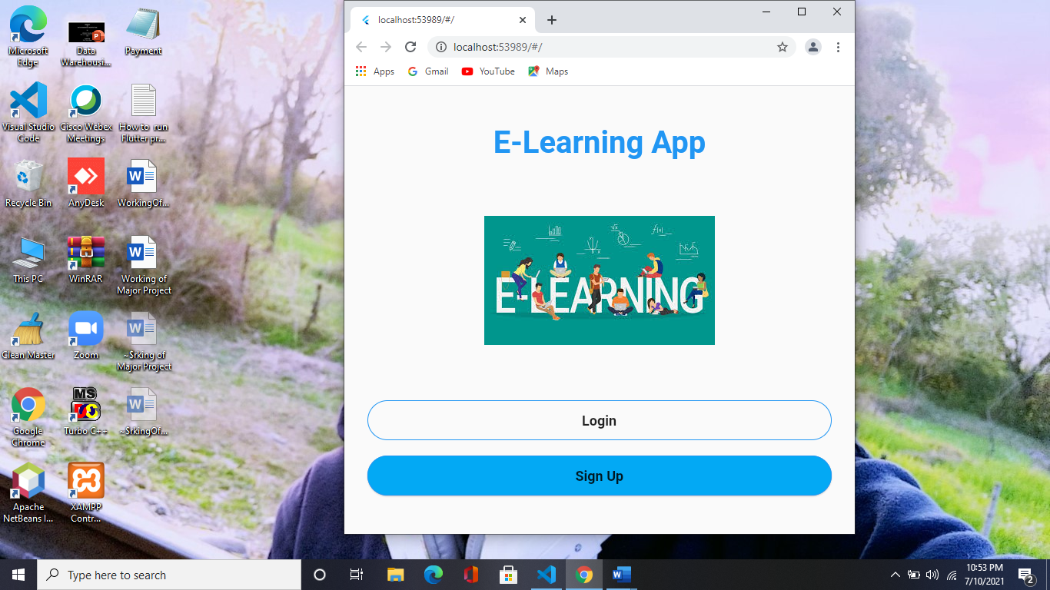

When click on **Login Button** then you see like this output

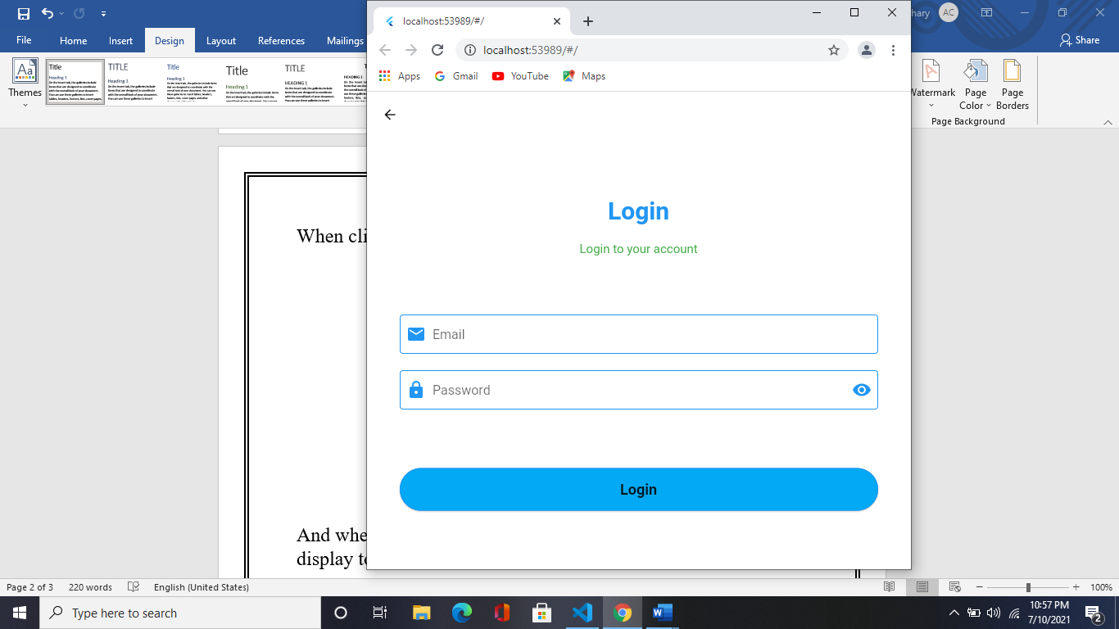

And when you click on **Sign Up button** then this screen will display to you

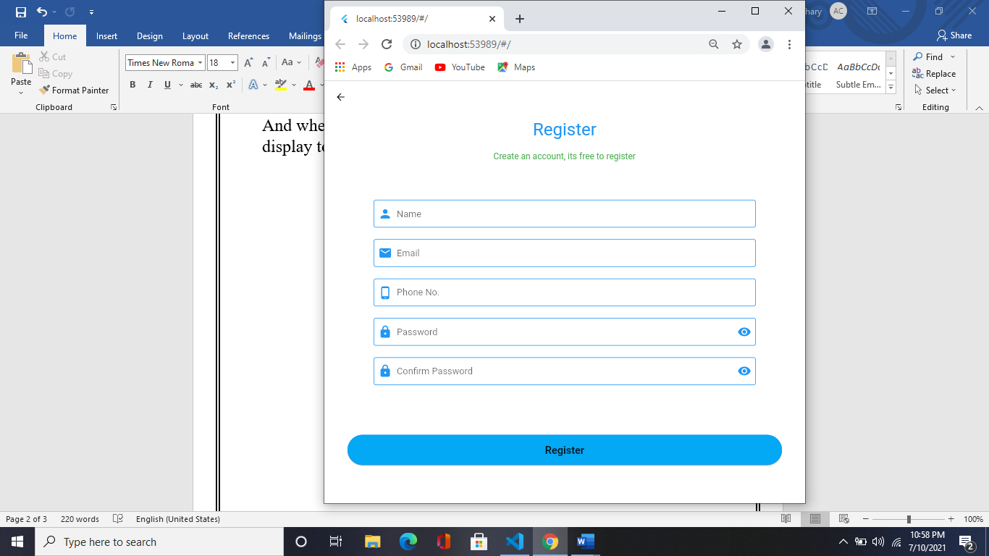

In Login screen I have add some validations

Just like

* When you empty the both textformfield value they give you error like **“Please Enter your value”**
* When you enter a Wrong email, they will give you an error

**“Please enter a valid email”**

You in login Screen That when you enter a password you see an icon by this icon you can see your password that you right

If your email and password are not getting match in shared preferences value yha not present in those values then you redirect to Register Screen

In that Register Screen you fill some details like

**Full Name, Email, Phone No., Password, Confirm Password**,

As a login screen I have add some small validations also

Like when you do not fill any textformfield then they give you an error like **Please enter your name**, password, email, confirm password etc.

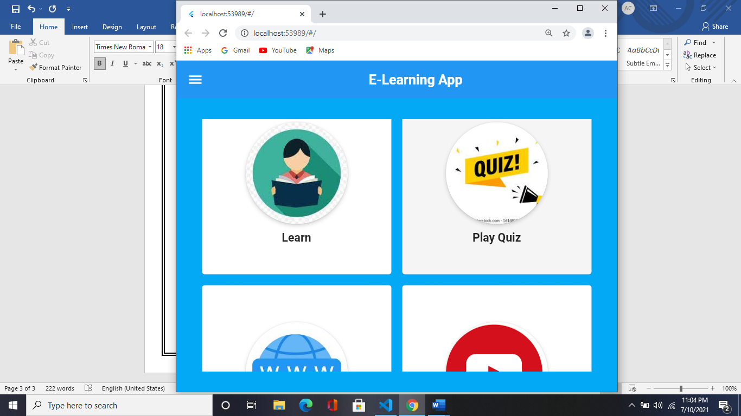After fill this all details then you **Login in** and then you redirect to this Screen

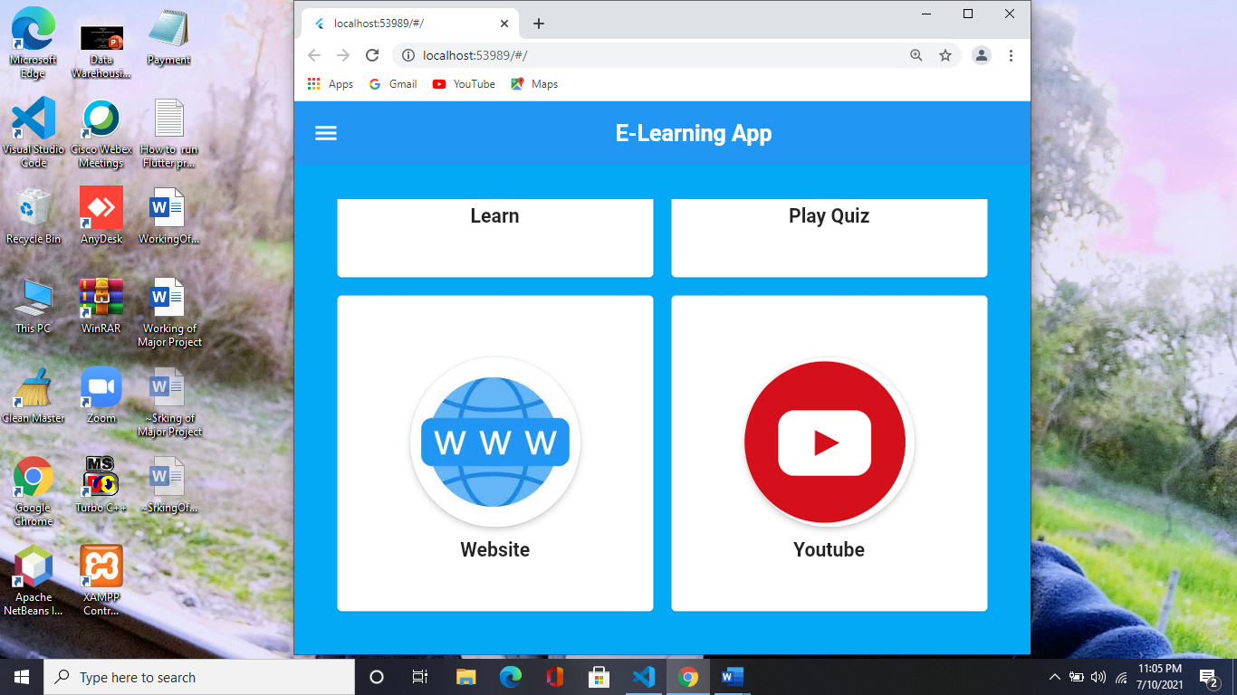

In this screen you see 4 menu items in screen like Learn, Play Quiz, Website, YouTube

1. 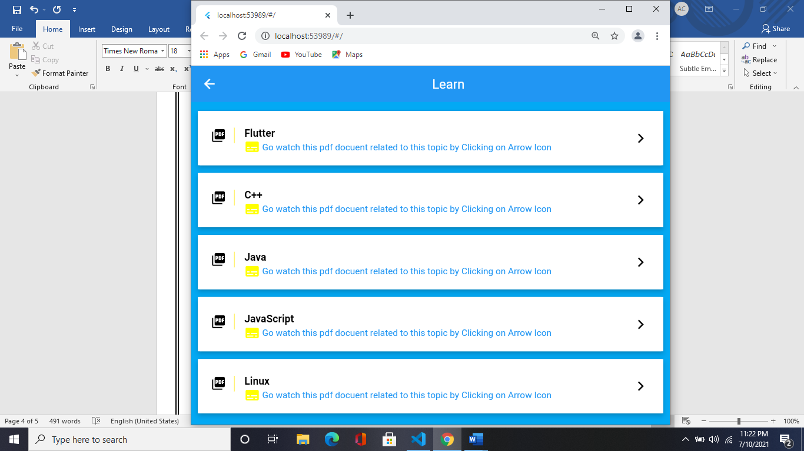Learn: - When you click on this you will redirect to this page like this

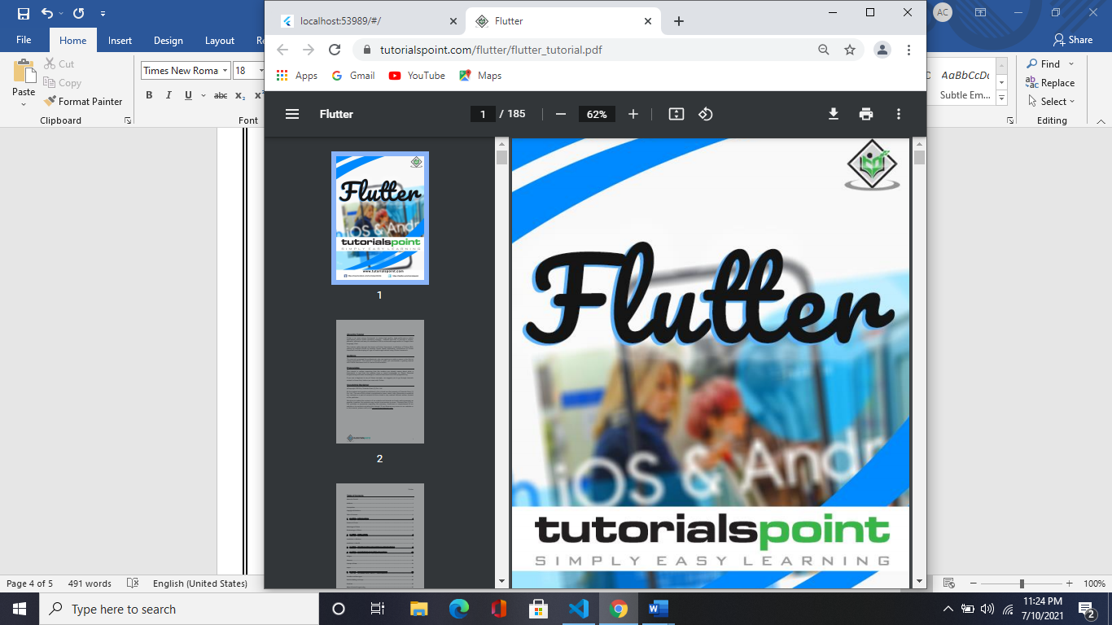In that you see some topics like Flutter, Java, C++, Linux etc. When you click on that arrow button you will see a pdf document related to this topic in that you see all the details about that topic.

1. 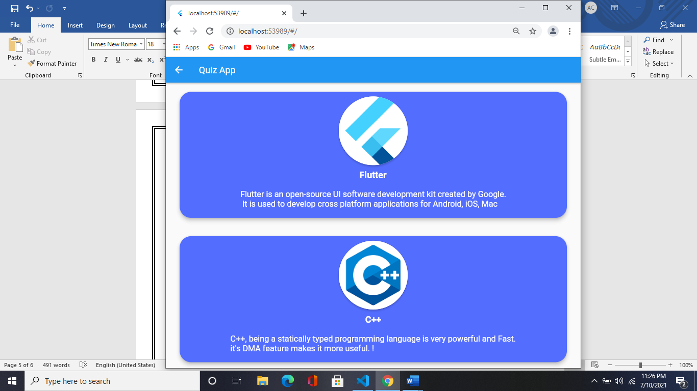Play Quiz: - When you click on this you will redirect to this page like this

In that you see some topics like Flutter, Java, C++, Linux etc. When you click on them you redirect to quiz page and you were start your quiz related to that topic.

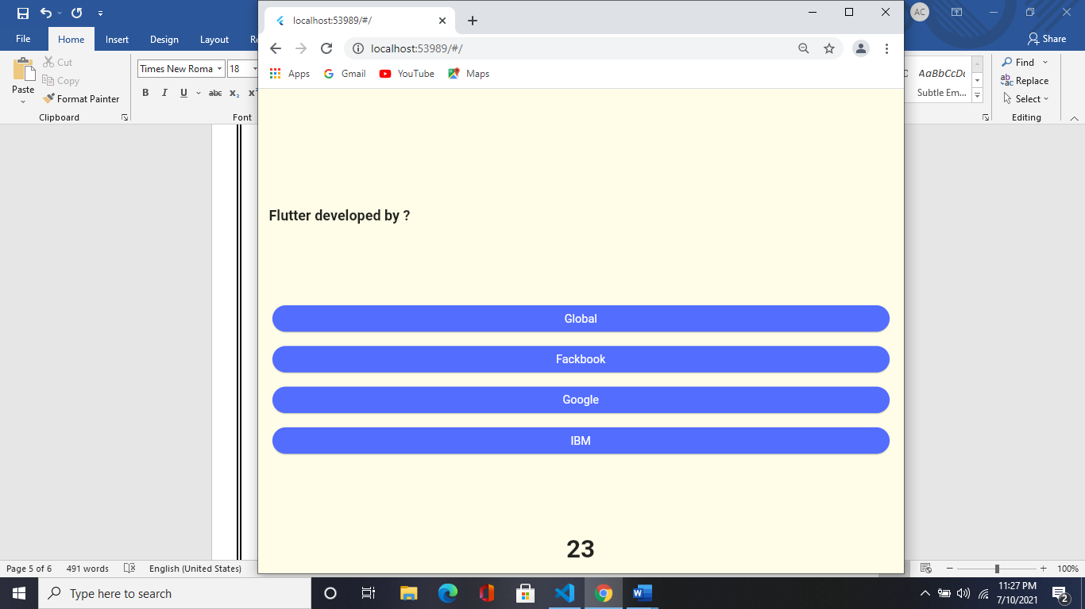

After finishing the Quiz, you see your result how you going to work by Score

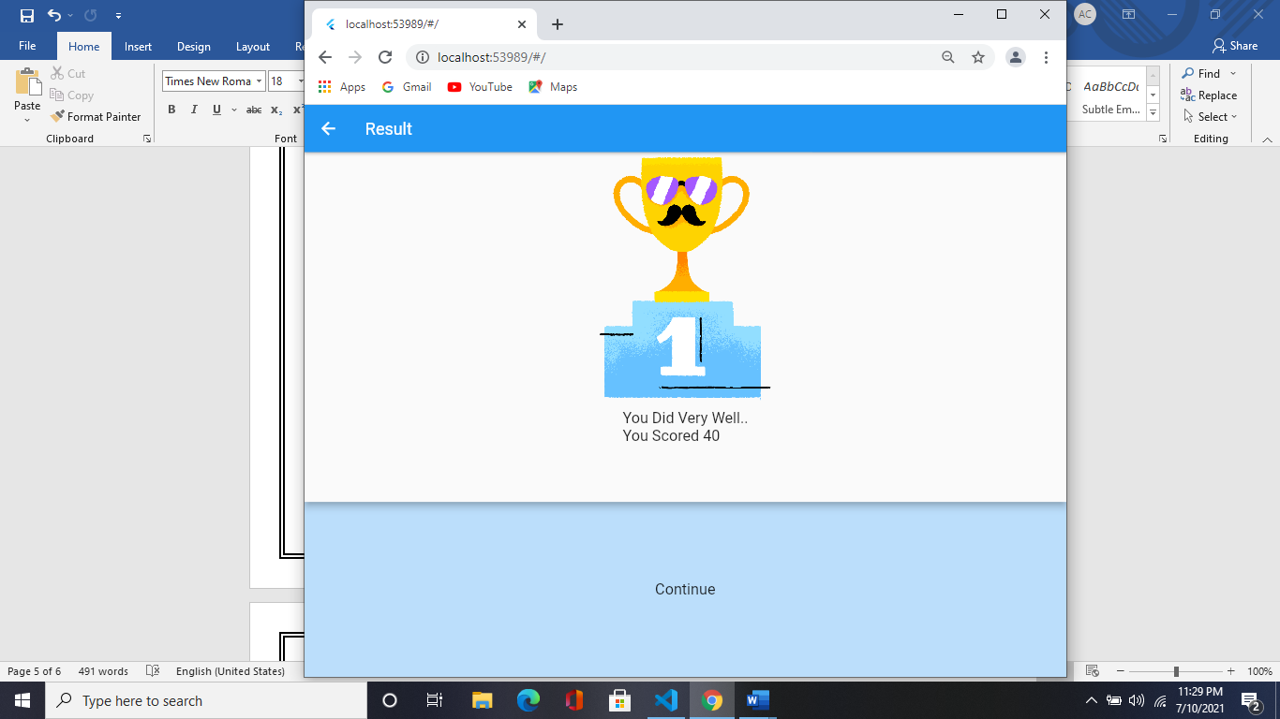

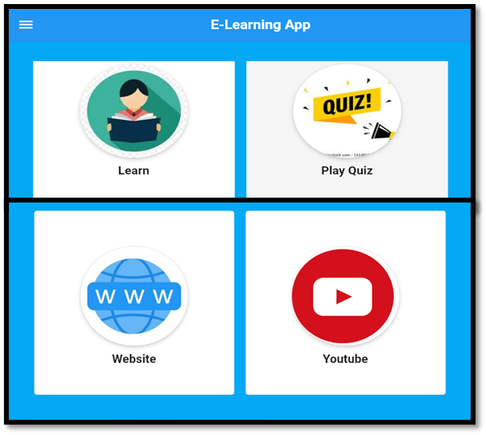After that when you click on Continue Button you redirect to this page.

1. Website: - When you click on this you will redirect to this page like this

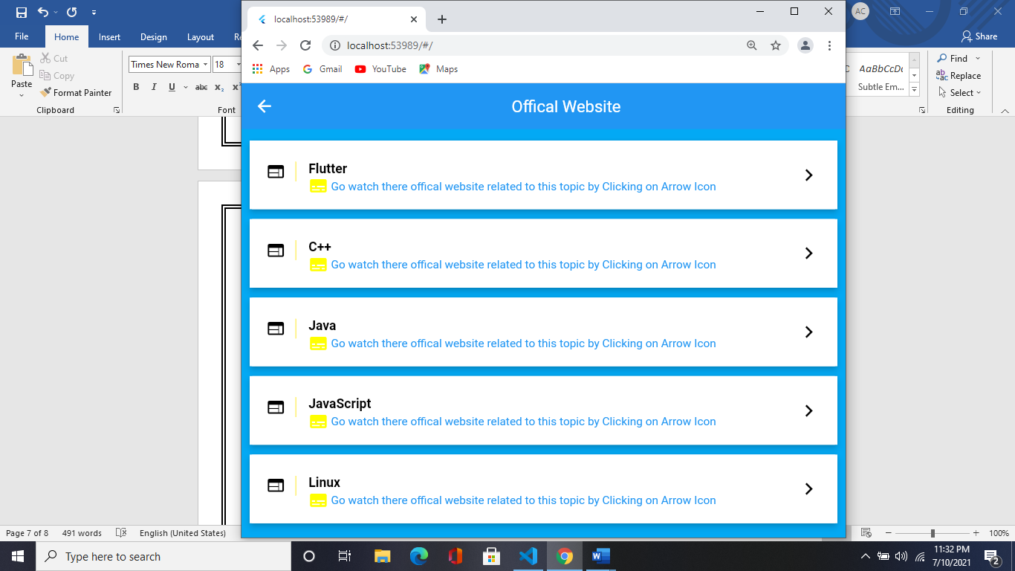

In that you see some topics like Flutter, Java, C++, Linux etc. When you click on that arrow button you will see a official website related to that topic in that you see all the details about that topic.

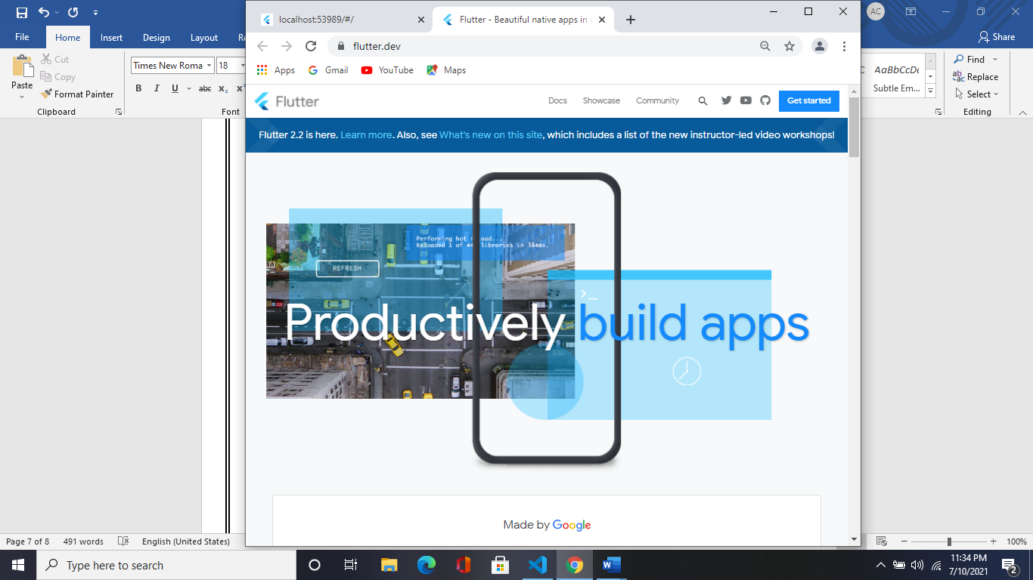

1. 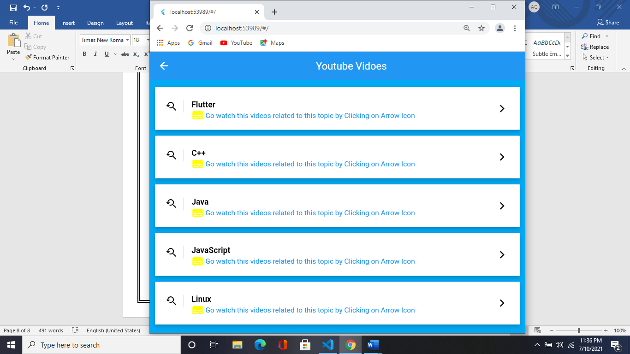YouTube: - When you click on this you will redirect to this page like this

In that you see some topics like Flutter, Java, C++, Linux etc. When you click on that arrow button you will see some videos related to that topic in that you see all the details about that topic. And go watch them you get all videos related to that topic.

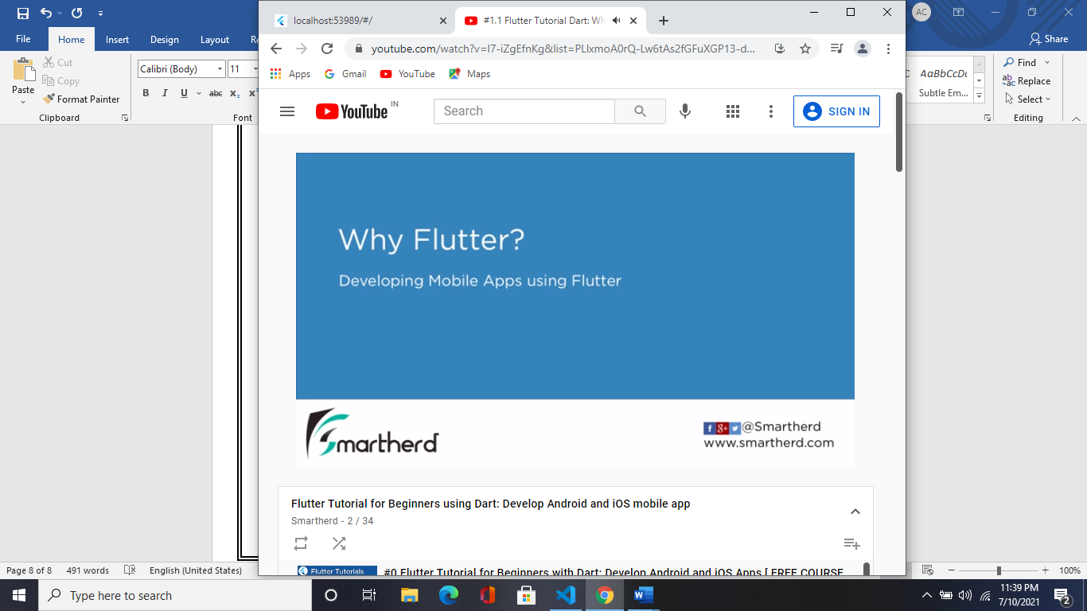

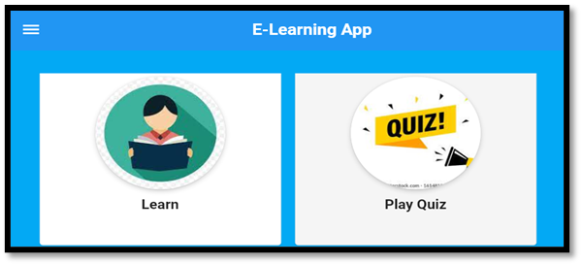When click on here then you see a Burger Menu

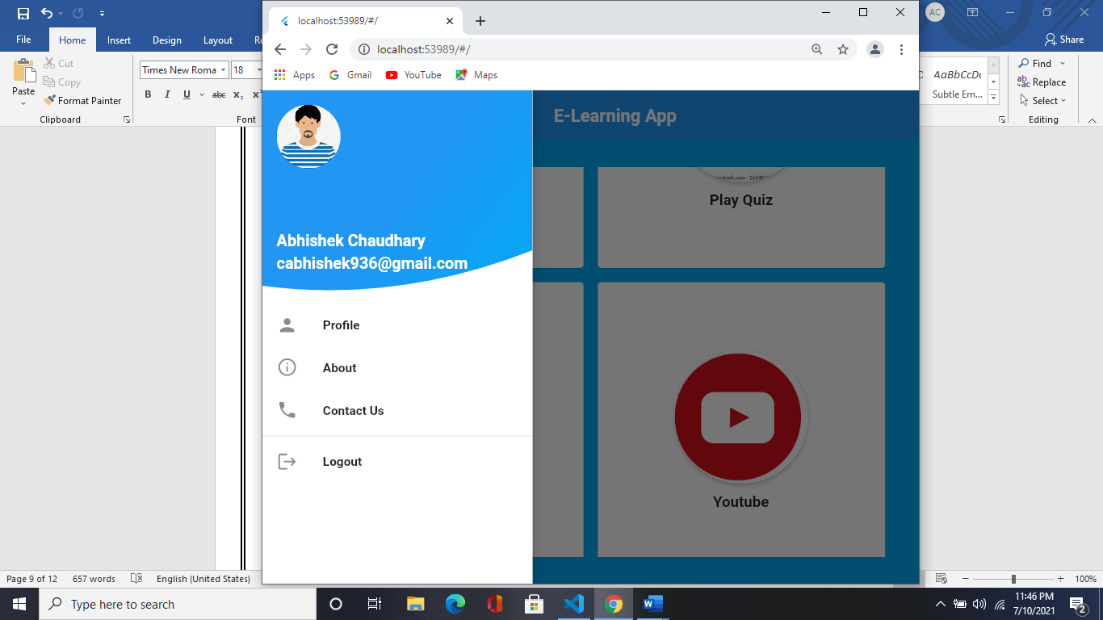Just like this

In this Burger menu I will add 4 different blocks

* In 1st block that see your detail like name and email are those when you enter it on register form

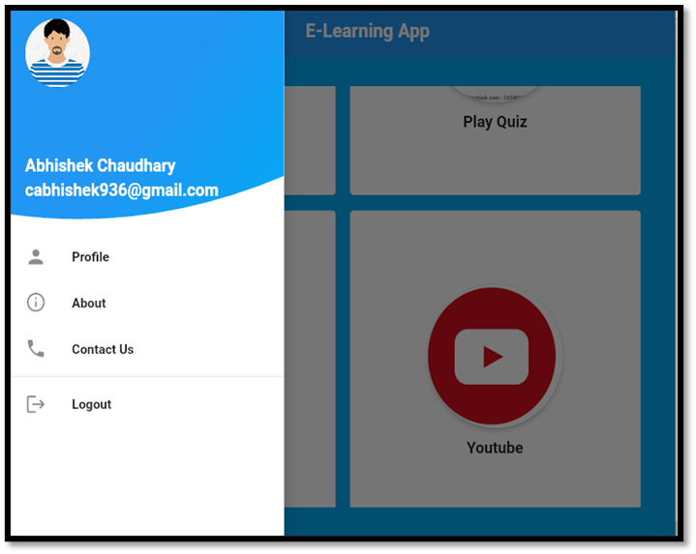

* In 2nd block that you see a **Profile** menu in that when you click on that you see our profile with your details like name, email, phone no etc. are those when you enter it on register form

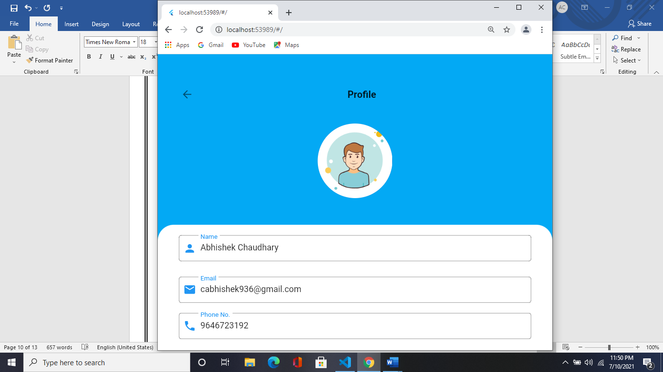

* In 3rd block you see that there is a **About** menu basically when you click on you go then you go to this page in that you see about app details yha introduction something like this

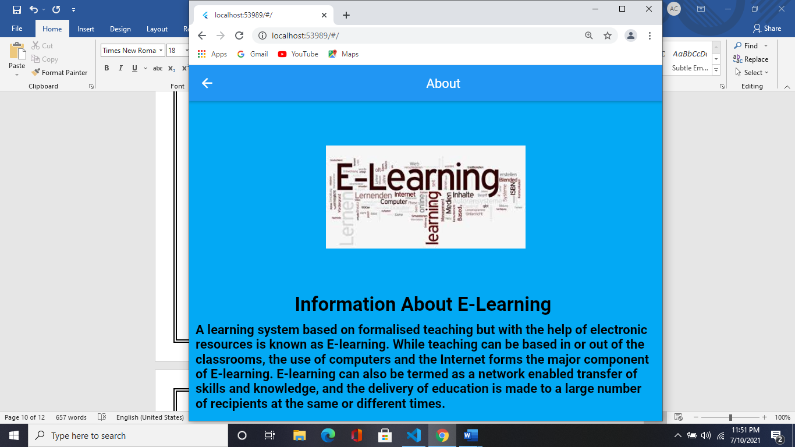

* In 4th block you see that there is a **Contact Us** menu basically when you click on then you go on to this page in that you can contact us

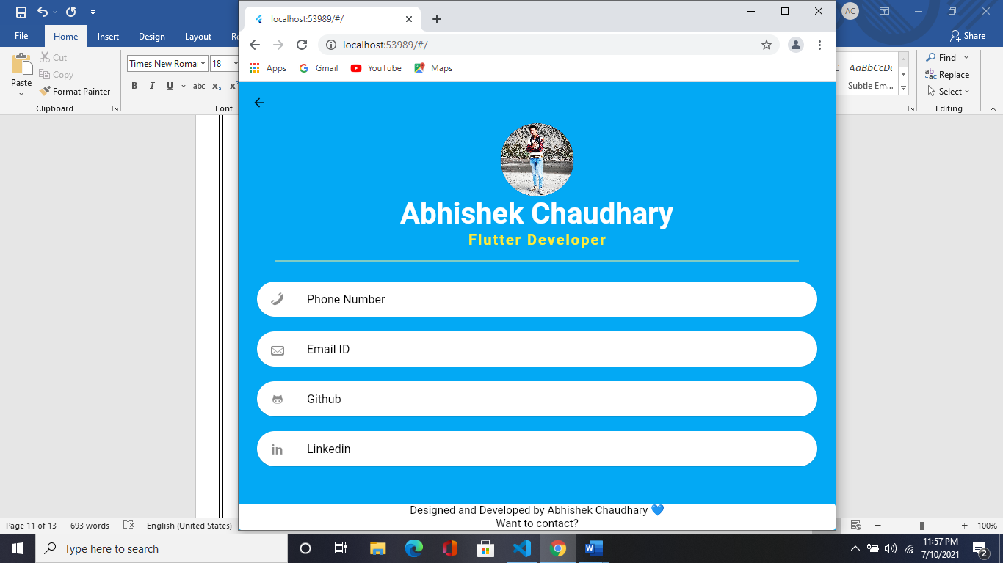

* In 5th when you click on **Logout**, they will show you an **Alter Dialog Box** in that

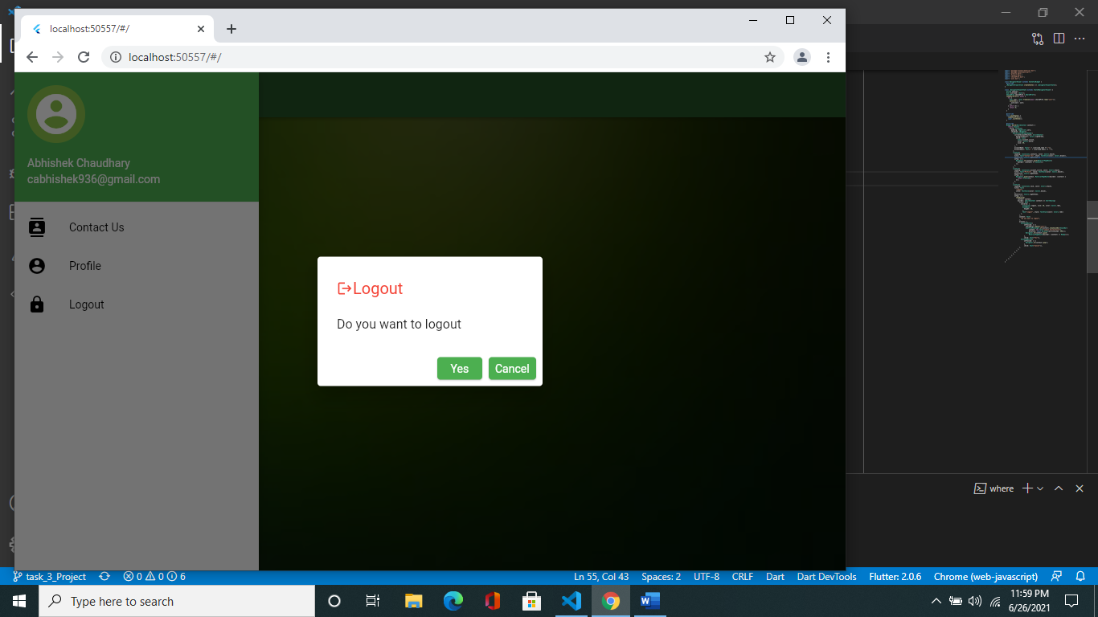

they will ask you that

**Do you want to logout**

**Yes Cancel**

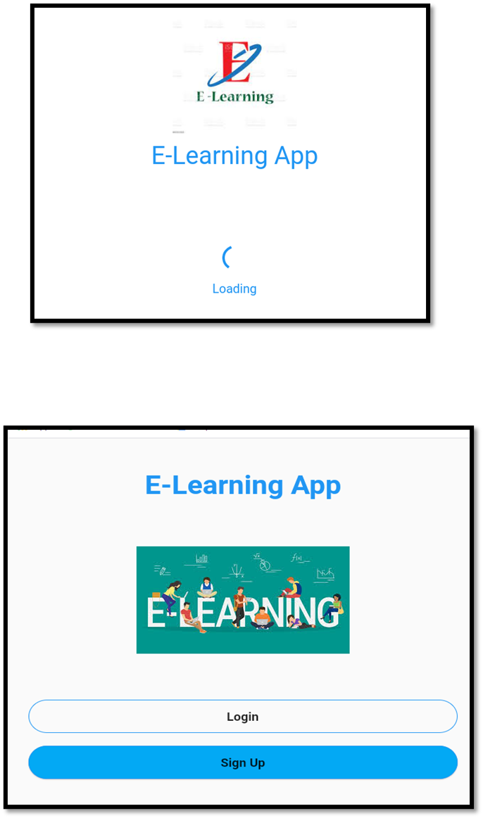When you clicked on **Yes** button then you will redirect to that screen

Otherwise, when you click on **Cancel** button then you redirect to that screen

